# 1
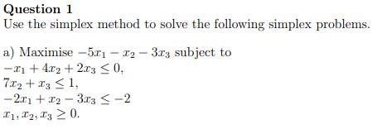
Part-a
 | x1 | x2 | x3 | bi | Ratio
y1 | -1 | 4 | 2 | 0 | 0 (smallest)
y2 | 0 | 7 | 1 | 1 | 1
y3 | -2 | 1 | -3 | -2
 | 5 | 1 | 3 | 0

 | x1 | x2 | y1 | bi | Ratio
x3 | -0.5 | 2 | 0.5 | 0
y2 | 0.5 | 5 | -0.5 | 1 | 2
y3 | -3.5 | 7 | 1.5 | -2
 | 6.5 | -5 | -1.5 | 0

 | y2 | x2 | y1 | bi | Ratio
x3 | 1 | 7 | 0 | 1 | 1
x1 | 2 | 10 | -1 | 2 | 1
y3 | 7 | 42 | -2 | 5 | 5/7 (smallest)
 | -13 | -70 | 5 | -13

 | y3 | x2 | y1 | bi
x3 | -0.14286 | 1 | 0.285714 | 0.285714
x1 | -0.28571 | -2 | -2.42857 | 0.571429
y2 | 0.142857 | 6 | -0.28571 | 0.714286
 | 1.857143 | 8 | 1.285714 | -3.71429

We conclude that the maximum value is -26/7 = -0.371429, achieved when x₁ = 4/7 = 0.571429, and x₂ = 0, and x₃ = 2/7= 0.285714.
Part-b
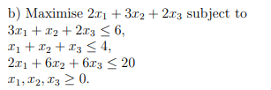

 | x1 | x2 | x3 | bi | Ratio
y1 | 3 | 1 | 2 | 6 | 6
y2 | 1 | 1 | 1 | 4 | 4
y3 | 2 | 6 | 6 | 20 | 3.333333 (smallest)
 | -2 | -3 | -2 | 0

 | x1 | y3 | x3 | bi | Ratio
y1 | 2.666667 | -0.16667 | 1 | 2.666667 | 1 (smallest)
y2 | 0.666667 | -0.16667 | 0 | 0.666667 | 1
x2 | 0.333333 | 0.166667 | 1 | 3.333333 | 10
 | -1 | 0.5 | 1 | 10

 | y1 | y3 | x3 | bi
x1 | 0.375 | -0.0625 | 0.375 | 1
y2 | -0.25 | -0.125 | -0.25 | 1.666667
x2 | -0.125 | 0.1875 | 0.875 | 3
 | 0.375 | 0.4375 | 1.375 | 11

We conclude that the maximum value is 11, achieved when x₁ = 1, and x₂ = 3, and x₃ = 0

Part-c
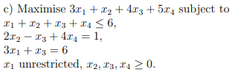
Replace the unrestricted variable x₁ by nonnegative u₁ and v₁ such that x₁ = u₁ – v₁
The constraint $2x_{2}-x_{3}+4x_{4}=1$ is equivalent to
$\left\{\begin{matrix}2x_{2}-x_{3}+4x_{4}≤1 \\ 2x_{2}-x_{3}+4x_{4}≥1\end{matrix}\right.$ or $\left\{\begin{matrix}2x_{2}-x_{3}+4x_{4}≤1 \\ -2x_{2}+x_{3}-4x_{4}≤-1\end{matrix}\right.$
The constraint $3x_{1}+x_{3}=6$ is equivalent to
$\left\{\begin{matrix}3x_{1}+x_{3}≤6 \\ 3x_{1}+x_{3}≥6\end{matrix}\right.$ or $\begin{matrix}3x_{1}+x_{3}≤6 \\ -3x_{1}-x_{3}≤-6\end{matrix}$
Next, replace $x_{1}$ by $u_{1}-v_{1}$
The LP is now
Maximize $3u_{1}-3v_{1}+x_{2}+4x_{3}+5x_{4}$ subject to
$$u_{1}-v_{1}+x_{2}+x_{3}+x_{4}≤6$$
$$2x_{2}-x_{3}+4x_{4}≤1$$
$$-2x_{2}+x_{3}-4x_{4}≤-1$$
$$3u_{1}-3v_{1}+x_{3}≤6$$
$$-3u_{1}+3v_{1}-x_{3}≤-6$$
$$u_{1},v_{1},x_{2},x_{3},x_{4}≥0$$

 | u1 | v1 | x2 | x3 | x4 | bi | Ratio
y1 | 1 | -1 | 1 | 1 | 1 | 6 | 6
y2 | 0 | 0 | 2 | -1 | 4 | 1 | 0.5 (smallest)
y3 | 0 | 0 | -2 | 1 | -4 | -1
y4 | 3 | -3 | 0 | 1 | 0 | 6
y5 | -3 | 3 | 0 | -1 | 0 | -6
 | -3 | 3 | -1 | -4 | -5 | 0

 | u1 | v1 | y2 | x3 | x4 | bi | Ratio
y1 | 1 | -1 | -0.5 | 1.5 | -1 | 5.5 | 5.5
x2 | 0 | 0 | 0.5 | -0.5 | 2 | 0.5
y3 | 0 | 0 | 1 | 0 | 0 | 0
y4 | 3 | -3 | 0 | 1 | 0 | 6 | 2 (smallest)
y5 | -3 | 3 | 0 | -1 | 0 | -6
 | -3 | 3 | 0.5 | -4.5 | -3 | 0.5

 | y4 | v1 | y2 | x3 | x4 | bi | Ratio
y1 | -0.33333 | 0 | -0.5 | 1.166667 | -1 | 3.5
x2 | 0 | 0 | 0.5 | -0.5 | 2 | 0.5 | 0.25 (smallest)
y3 | 0 | 0 | 1 | 0 | 0 | 0
u1 | 0.333333 | -1 | 0 | 0.333333 | 0 | 2
y5 | 1 | 0 | 0 | 0 | 0 | 0
 | 1 | 0 | 0.5 | -3.5 | -3 | 6.5

 | y4 | v1 | y2 | x3 | x2 | bi | Ratio
y1 | -0.33333 | 0 | -0.25 | 0.916667 | 0.5 | 3.75 | 4.09 (smallest)
x4 | 0 | 0 | 0.25 | -0.25 | 0.5 | 0.25
y3 | 0 | 0 | 1 | 0 | 0 | 0
u1 | 0.333333 | -1 | 0 | 0.333333 | 0 | 2 | 6
y5 | 1 | 0 | 0 | 0 | 0 | 0
 | 1 | 0 | 1.25 | -4.25 | 1.5 | 7.25

 | y4 | v1 | y2 | y1 | x2 | bi | Ratio
x3 | -0.36364 | 0 | -0.27273 | 1.090909 | 0.545455 | 4.090909
x4 | -0.09091 | 0 | 0.181818 | 0.272727 | 0.636364 | 1.272727
y3 | 0 | 0 | 1 | 0 | 0 | 0
u1 | 0.454545 | -1 | 0.090909 | -0.36364 | -0.18182 | 0.636364 | 1.4
y5 | 1 | 0 | 0 | 0 | 0 | 0 | 0 (smallest)
 | -0.54545 | 0 | 0.090909 | 4.636364 | 3.818182 | 24.63636

 | y5 | v1 | y2 | y1 | x2 | bi
x3 | 0.363636 | 0 | -0.27273 | 1.090909 | 0.545455 | 4.090909
x4 | 0.090909 | 0 | 0.181818 | 0.272727 | 0.636364 | 1.272727
y3 | 0 | 0 | 1 | 0 | 0 | 0
u1 | -0.45455 | -1 | 0.090909 | -0.36364 | -0.18182 | 0.636364
y4 | 1 | 0 | 0 | 0 | 0 | 0
 | 0.545455 | 0 | 0.090909 | 4.636364 | 3.818182 | 24.63636
We conclude that the maximum value is 271/11= 24.6363, achieved when
x₁ = u₁ - v₁ = 0.6363 – 0 = 0.6363 or 7/11,
x₂ = 0,
x₃ = 4.0909 or 45/11
x₄ = 1.2727 or 14/11

# 2
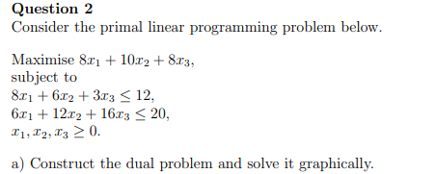
Part-a
The dual of the problem is
Minimize $z=12y_{1}+20y_{2}$ subject to
$$8y_{1}+6y_{2}≥8$$
$$6y_{1}+12y_{2}≥10$$
$$3y_{1}+16y_{2}≥8$$
$$y_{1},y_{2}≥0$$

Here’s the graph including points of intersection (corner points)
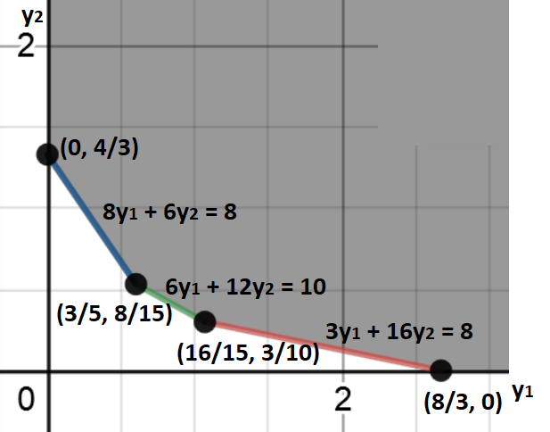

Corner Point (y₁, y₂) | value of Objective Function z = 12y₁ + 20y₂
(0, 4/3) | 80/3 = 26.67
(3/5, 8/15) | 268/15 = 17.87
(16/15, 3/10) | 94/5 = 18.8
(8/3, 0) | 32

Therefore, the minimum value of the objective is 268/15 = 17.87 and it is achieved when y₁ = 3/5 and y₂ = 8/15

Part-b
We use the correspondence
$\begin{matrix}\begin{matrix}Primal \\ x_{1} \\ x_{2}\end{matrix} & \begin{matrix} \\ ⟺ \\ ⟺\end{matrix} & \begin{matrix}Dual \\ s_{1}' \\ s_{2}'\end{matrix} \\ \begin{matrix}x_{3} \\ s_{1} \\ s_{2}\end{matrix} & \begin{matrix}⟺ \\ ⟺ \\ ⟺\end{matrix} & \begin{matrix}s_{3}' \\ y_{1} \\ y_{2}\end{matrix}\end{matrix}$
where $s_{1}$and $s_{2}$are slack/surplus variables in the primal and $s_{1}'$, $s_{2}'$, and $s_{3}'$ are slack/surplus variables in the dual
Given the optimal solution in the dual is y₁ = 3/5 and y₂ = 8/15
$$8y_{1}+6y_{2}-s_{1}'=8$$
$$6y_{1}+12y_{2}-s_{2}'=10$$
$$3y_{1}+16y_{2}-s_{3}'=8$$
implies that $s_{1}'=0$, $s_{2}'=0$, and $s_{3}'=7/3$
We know that the optimal solution in the primal is
$s_{1}=0$, $s_{2}=0$, and $x_{3}=0$
Substitute in $\left\{\begin{matrix}8x_{1}+6x_{2}+3x_{3}+s_{1}=12 \\ 6x_{1}+12x_{2}+16x_{3}+s_{2}=20\end{matrix}\right.$
$\left\{\begin{matrix}8x_{1}+6x_{2}=12 \\ 6x_{1}+12x_{2}=20\end{matrix}\right.$ $⇒$ $x_{1}=\frac{2}{5}$ and $x_{2}=\frac{22}{15}$ and $x_{3}=0$and the optimal value in the primal is
$z=8\left(\frac{2}{5}\right)+10\left(\frac{22}{15}\right)+8\left(0\right)=\frac{268}{15}$ or approximately 17.87

# 3
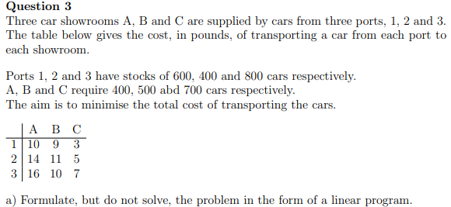
Part-a
Let $P_{1}$, $P_{2}$, and $P_{3}$ denote the three ports 1, 2, and 3 respectively
Let $M_{1}$, $M_{2}$, and $M_{3}$ denote the three car showrooms A, B, and C respectively
Let $y_{ij}=$ quantity of the cars shipped from port $P_{i}$ to market $M_{j}$
We want to minimize the total transportation cost
$$z=10{ y}_{11}+9y_{12}+3y_{13}+14y_{21}+11y_{22}+5y_{23}+16y_{31}+10y_{32}+7y_{33}$$
subject to
$$\left\{\begin{matrix}y_{11}+y_{12}+y_{13}≤600 \\ y_{21}+y_{22}+y_{23}≤400 \\ y_{31}+y_{32}+y_{33}≤800\end{matrix}\right.$$
$$\left\{\begin{matrix}y_{11}+y_{21}+y_{31}≥400 \\ y_{12}+y_{22}+y_{32}≥500 \\ y_{13}+y_{23}+y_{33}≥700\end{matrix}\right.$$
and the non-negativity constraint
$y_{ij}≥0$ for $i=1,2,3$ and $j=1,2,3$

Part-b
We add dummy column (dummy market) since total supply (1,800) is more than the total demand (1,600)
 | M1 |  | M2 |  | M3 |  | M4
P1 | 10 |  | 9 |  | 3 |  | 0 |  | 600
P2 | 14 |  | 11 |  | 5 |  | 0 |  | 400
P3 | 16 |  | 10 |  | 7 |  | 0 |  | 800
 | 400 |  | 500 |  | 700 |  | 200 |  | 1800

Part-c
Using least cost rule and ignoring the allocation to the dummy market, the array is
 | M1 |  | M2 |  | M3 |  | M4
P1 | 10 |  | 9 |  | 3 |  | 0 |  | 600
P1 |  |  |  |  |  | [600] |  |  | 600
P2 | 14 |  | 11 |  | 5 |  | 0 |  | 400
P2 |  | [300] |  |  |  | [100] |  |  | 400
P3 | 16 |  | 10 |  | 7 |  | 0 |  | 800
P3 |  | [100] |  | [500] |  |  |  |  | 800
 | 400 |  | 500 |  | 700 |  | 200 |  | 1800

Now, we check for optimality
Let $u_{3}=0$ and $v_{ij}-u_{ij}=b_{ij}$ for all circled entries
 | 16 |  | 10 |  | 7 |  | M4
4 | 10 |  | 9 |  | 3 |  | 0 |  | 600
4 |  |  |  |  |  | [600] |  |  | 600
2 | 14 |  | 11 |  | 5 |  | 0 |  | 400
2 |  | [300] |  |  |  | [100] |  |  | 400
0 | 16 |  | 10 |  | 7 |  | 0 |  | 800
0 |  | [100] |  | [500] |  |  |  |  | 800
 | 400 |  | 500 |  | 700 |  | 200 |  | 1800

However, 16-4 in the upper left portion exceeds 10 so solution is not optimal.
 | 16 |  | 10 |  | 7 |  | 0
4 | 10 |  | 9 |  | 3 |  | 0 |  | 600
4 |  | $+θ$ |  |  |  | [600]$-θ$ |  |  | 600
2 | 14 |  | 11 |  | 5 |  | 0 |  | 400
2 |  | [300]$-θ$ |  |  |  | [100]+$θ$ |  |  | 400
0 | 16 |  | 10 |  | 7 |  | 0 |  | 800
0 |  | [100] |  | [500] |  |  |  |  | 800
 | 400 |  | 500 |  | 700 |  | 200 |  | 1800

Take $θ=min(300, 600)=300$
 | 16 |  | 10 |  | 9 |  | 0
6 | 10 |  | 9 |  | 3 |  | 0 |  | 600
6 |  | [300] |  |  |  | [300] |  |  | 600
4 | 14 |  | 11 |  | 5 |  | 0 |  | 400
4 |  |  |  |  |  | [400] |  |  | 400
0 | 16 |  | 10 |  | 7 |  | 0 |  | 800
0 |  | [100] |  | [500] |  |  |  |  | 800
 | 400 |  | 500 |  | 700 |  | 200 |  | 1800

However, 9-0=9 exceeds 7 in the 3rd row and 3rd column
 | 16 |  | 10 |  | 9 |  | 0
6 | 10 |  | 9 |  | 3 |  | 0 |  | 600
6 |  | [300]$+θ$ |  |  |  | [300]$-θ$ |  |  | 600
4 | 14 |  | 11 |  | 5 |  | 0 |  | 400
4 |  |  |  |  |  | [400] |  |  | 400
0 | 16 |  | 10 |  | 7 |  | 0 |  | 800
0 |  | [100]$-θ$ |  | [500] |  | $+θ$ |  |  | 800
 | 400 |  | 500 |  | 700 |  | 200 |  | 1800

Take $θ=min(100, 300)=100$
 | 14 |  | 10 |  | 7
4 | 10 |  | 9 |  | 3 |  | 0 |  | 600
4 |  | [400] |  |  |  | [200] |  |  | 600
2 | 14 |  | 11 |  | 5 |  | 0 |  | 400
2 |  |  |  |  |  | [400] |  |  | 400
0 | 16 |  | 10 |  | 7 |  | 0 |  | 800
0 |  |  |  | [500] |  | [100] |  |  | 800
 | 400 |  | 500 |  | 700 |  | 200 |  | 1800

All non-circled cells satisfy $v_{ij}-u_{ij}≤b_{ij}$
Therefore,
Transport 400 cars from Port 1 to Market A
Transport 200 cars from Port 1 to Market C
Transport 400 cars from Port 2 to Market C
Transport 500 cars from Port 3 to Market B
Transport 100 cars from Port 3 to Market C
The minimum total cost is 10*400 + 3*200 + 5*400 + 10*500+ 7*100 = 12,300

# 4
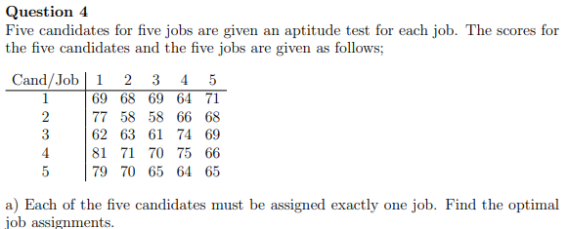
Part-a
Matrix S
Matrix S
Cand/Job | 1 | 2 | 3 | 4 | 5
1 | 12 | 13 | 12 | 17 | 10
2 | 4 | 23 | 23 | 15 | 13
3 | 19 | 18 | 20 | 7 | 12
4 | 0 | 10 | 11 | 6 | 15
5 | 2 | 11 | 16 | 17 | 16

Step 1
Cand/Job | 1 | 2 | 3 | 4 | 5
1 | 2 | 3 | 2 | 7 | 0
2 | 0 | 19 | 19 | 11 | 9
3 | 12 | 11 | 13 | 0 | 5
4 | 0 | 10 | 11 | 6 | 15
5 | 0 | 9 | 14 | 15 | 14

Step 2
Cand/Job | c 1 | 2 | 3 | 4 | 5
c 1 | 2 | 0 | 0 | 7 | 0
2 | 0 | 16 | 17 | 11 | 9
c 3 | 12 | 8 | 11 | 0 | 5
4 | 0 | 7 | 9 | 6 | 15
5 | 0 | 6 | 12 | 15 | 14

Step 3
The maximum number of independent zeros is $k_{m}=$3

Step 4
The smallest element of non-covered elements is h =6
We add 6 to each twice covered element of A
We subtract 6 from each non-covered elements

Step 4
Cand/Job | c 1 | c 2 | 3 | c 4 | 5
c 1 | 8 | 0 | 0 | 7 | 0
2 | 0 | 10 | 11 | 5 | 3
3 | 18 | 8 | 11 | 0 | 5
4 | 0 | 1 | 3 | 0 | 9
5 | 0 | 0 | 6 | 9 | 8

There are 4 independent zeros and the smallest of non-covered elements is $h=$3
We add 3 to each twice covered element of A
We subtract 3 from each non-covered elements

Step 4.2
Cand/Job | 1 | 2 | 3 | 4 | 5
c 1 | 11 | 3 | 0* | 10 | 0
c 2 | 0 | 10 | 8 | 5 | 0*
c 3 | 18 | 8 | 8 | 0* | 2
c 4 | 0 | 1 | 0 | 0 | 6
c 5 | 0 | 0* | 3 | 9 | 5

There are 5 independent zeros, therefore assign
job 3 to candidate 1
job 5 to candidate 2
job 4 to candidate candidate 3
job 1 to candidate 4
job 2 to candidate 5

The maximum value of r is 69 + 68 + 74 + 81 + 70 = 362

We can also assign
job 5 to candidate 1
job 1 to candidate 2
job 4 to candidate candidate 3
job 3 to candidate 4
job 2 to candidate 5

The maximum value of r is 71 + 77 + 74 + 70 + 70 = 362

Part-b
Matrix S
Cand/ Job | 1 | 3 | 4 | 5
1 | 12 | 12 | 17 | 10
3 | 19 | 20 | 7 | 12
4 | 0 | 11 | 6 | 15
5 | 2 | 16 | 17 | 16

Step 1 of Part b
Cand/ Job | 1 | 3 | 4 | 5
1 | 2 | 2 | 7 | 0
3 | 12 | 13 | 0 | 5
4 | 0 | 11 | 6 | 15
5 | 0 | 14 | 15 | 14

Step 2 of Part b
Cand/ Job | c 1 | 3 | 4 | 5
c 1 | 2 | 0 | 7 | 0
c 3 | 12 | 11 | 0 | 5
4 | 0 | 9 | 6 | 15
5 | 0 | 12 | 15 | 14

There are 3 independent zeros and the smallest of non-covered elements is $h=$ 6
We add 6 to each twice covered element of A
We subtract 6 from each non-covered elements

Step 3 of b
Cand/ Job | c 1 | 3 | c 4 | 5
c 1 | 8 | 0 | 7 | 0
3 | 18 | 11 | 0 | 5
4 | 0 | 3 | 0 | 9
5 | 0 | 6 | 9 | 8

There are 3 independent zeros and the smallest of non-covered elements is $h=$ 3
We add 3 to each twice covered element of A
We subtract 3 from each non-covered elements
Step 3.2
Cand/ Job | c 1 | 3 | C 4 | 5
c 1 | 11 | 0 | 10 | 0
3 | 18 | 8 | 0 | 2
c4 | 0 | 0 | 0 | 6
5 | 0 | 3 | 9 | 5

There are 4 independent zeros, therefore assign
job 5 to candidate 1
job 4 to candidate 3
job 3 to candidate candidate 4
job 1 to candidate 5

The maximum value of r (excluding candidate 2 ) is 71 + 74 + 70 + 79 = 294 (excluding candidate 2)

